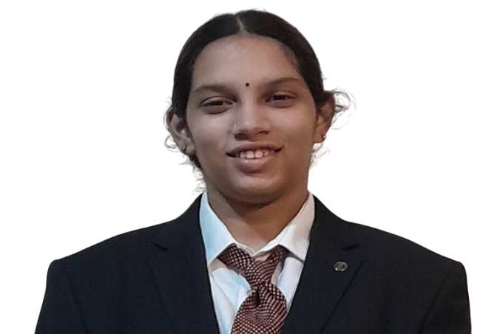 **Profile**

Name : N T Keerrthana

Father's Name : T.R. Thyagharaajan

Mothers Name : Meena Thyagharaajan

DOB & Age : 31st October 2007, 17 years

Residence Address : Flat No. 10, Kamal Apartments

New No. 45/23,

R A Puram 1st cross Street

R A Puram 4th Main Road

Raja Annamalaipuram

Chennai – 600 028

(M) 98840 20455

(M) 72990 53758

School : P S Senior Secondary School,

Alarmelmangapuram, Mylapore, Chennai - 600004

Std : 12th

|  |  |
| --- | --- |
| **Class 10** | **92.6%** |
| **Class 12** | **75%** |

**Educational Achievements:**

|  |  |  |
| --- | --- | --- |
| 19th February 2023 | Hybrid Rocket Launch of 150 Pico satellites | Dr. APJ Abdul Kalam Satellite Launch Vehicle Mission-2023  Launching 150 Pico satellites in a hybrid rocket  It was later announced as world record |
| 15th October 2023 | Astrophysics and Space Technogy | CHANDRAYAAN 3 – THE TRIUMPH –  Space Debris Mitigation and Active Removal – PPT presentation, House of Kalam Rameshwaram |
| 30th September 2024 | Computer Science | White Hat Hackers – CICADA’24 – SRM Vadapalani  Won 2nd price in PYTHON PUZZLE HUNT |
| 15th October 2024 | Astrophysics and Space Technology | Inspiring Innovation and Excellence – APJ Abdul Kalam Memorial Dilli Hatt, Delhi  Won 1st price for Space Debris Mitigation and Active removal |

**Sponsorship:**

|  |  |  |
| --- | --- | --- |
| 2022 – 2023  2023 – 2024  2024 – 2025 | Joint Entrance Examination  (JEE) coaching class at Ahaguru | Prof Dr D P Sankaran Ph.D  (Retd. Chemistry HOD,  Loyola College)  Chemistry Professor  AhaGuru Coaching Centre  IIT JEE + CBSE + NEET |

**Notable Awards and Recognitions:**

|  |  |  |
| --- | --- | --- |
| May 2017 | Keyboard (Group) | * Participated and won Guinness Book of Records (Event conducted by Mr. Martin) * 440 children played keyboard together) * Recognised as Asia book of records |
| 12th Nov 2017 | Carnatic Vocal (Individual)  Keyboard (Individual) | Recognised for winning Guinness Book of Records and Asia Book of Records  By R A Puram Association |
| 10th May 2019 | Carnatic Vocal (Group) | DD Podhigai - Isaithopu – Season 7  Won 2nd Prize – Cash award of Rs. 10000 |
| 30th May 2019 | Carnatic Vocal (Individual)  Keyboard (Individual) | Lakshmi Giri Hall, Mylapore, Chennai – 600004 |

**Other Notable Awards and Recognitions:**

|  |  |  |
| --- | --- | --- |
| 31st Aug 2013 | Mental Arithmatics | Ideal Play Abacus India Limited – Level 1  All India – 1st prize |
| May 2014 | Olympiad - Computer Science | EduHeal Olympiad  Tamil Nadu – 3rd Prize |
| 8th Dec 2013 | Mental Arithmatics | Ideal Play Abacus India Limited - Level 1  Tamil Nadu – 3rd Prize |
| 19th Oct 2014 | Mental Arithmatics | Ideal Play Abacus India Limited – Level 4  Tamil Nadu – 3rd Prize |
| 11th Jan 2015 | Mental Arithmatics | Ideal Play Abacus India Limited - Level 4  All India – 5th Prize |

**Other Interests:**

|  |  |  |
| --- | --- | --- |
| **Carnatic Vocal** | **Period** | **Name of the Guru** |
| 4 years | Oct 2013 to Nov 2017 | Smt. Pushpa Sampathkumaran |
| 4 months | Dec 2017 to Mar 2018 | Dr. Smt. Shubha Ganesan |
| 3 years & 1 month | Apr 2018 to Apr 2021 | Smt. Bagyalakshmi Suresh |
| 11 months | May 2021 to Apr 2022 | Shri. Krishna Pawan Kumar |
| Total – 8 years 4 months | | |

|  |  |  |
| --- | --- | --- |
| **Keyboard Instrument** | **Period** | **Name of the Guru** |
| 3.5 years | Oct 2014 to Mar 2018 | Smt. Pushpa Sampathkumaran |
| 3 years & 9 months | Sep 2018 to Jun 2022 | Shri. Vishal Ramasamy |
| **Total – 7 years 3 months** | | |

|  |  |  |
| --- | --- | --- |
| **Piano** | **Period** | **Name of the Guru** |
| 7 months | May 2020 | Shri. Aadhithyan Ramanathan |

|  |  |  |
| --- | --- | --- |
| ***Program*** | ***Vocal / Instrument*** | ***Venue*** |
| 29th Aug 2014 | Carnatic Vocal (Group) &  Keyboard (Individual) | Sri Nagalakshmi Narayanamoorthy Temple (Puthu Temple), R A Puram, Chennai - 6000028 |
| Aug 2015 | Carnatic Vocal (Group) &  Keyboard (Individual) | Vinayagar temple, Alwarpet, Chennai – 600018 |
| Aug 2016 | Carnatic Vocal (Individual) &  Keyboard (Individual) | Vinayagar temple, Alwarpet, Chennai – 600018 |
| Aug 2016 | Carnatic Vocal (Group) &  Keyboard (Individual) | Sundaram Sri Sathya Sai Baba Temple, R A Puram, Chennai – 600 028 |
| Sep 2016 | Carnatic Vocal (Group) | Sri Siddhi Budhi Vinayagar temple, R A puram, Chennai – 600 028 |
| Jan 2017 | Carnatic Vocal (Individual) | Republic Day Function, R A Puram, Chennai – 600 028 |
| 2nd Jun 2017 | Carnatic Vocal (Group) | In front of H H  Shri Bala Periyava  Sankara Matriculation School, Thoraipakkam, Chennai – 600 097 |
| Aug 2017 | Carnatic Vocal (Group) &  Keyboard (Individual) | Sundaram Sri Sathya Sai Baba Temple, R A Puram, Chennai – 600 028 |
| Sep 2017 | Carnatic Vocal (Group) | Sri Siddhi Bhuddhi Vinayagar temple, R A puram, Chennai – 600 028 |
| Nov 2017 | Carnatic Vocal (Individual) | R A Puram residents association quarterly meet (Wandering artist, R A puram), Chennai - 600028 |
| 7th Feb 2018 | Carnatic Vocal (Individual) | Chenna Kesava Perumal Temple, New Gummidipoondi (Organised by TTDC, T.Nagar, Chennai – 600 017) |
| 24th Mar 2018 | Carnatic Vocal (Group) | TTDC, T. Nagar, Chennai – 600 017 |
| Jul 2018 | Carnatic Vocal (Group) | In front of Shri. Nochur Venkatraman  Naradha Gana Sabha, TTK Road, Chennai – 600018 |
| 21st Jul 2019 | Carnatic Vocal (Group) | In front of Shri. Nochur Venkatraman  Naradha Gana Sabha, TTK Road, Chennai – 600018 |
| 23rd August 2019 | Carnatic Vocal (Individual) | Saiva samaya baktha jana sabhai, 222 Thangasalai. Park Town, Parrys, Chennai – 600003 (near Kandha kottam) |
| 28th September 2019 | Carnatic Vocal (Individual) | Navarathri Vaibhavam Kamakoti Guru Parampara, Bharathiya Vidhya Bhavan, East Mada street, Mylapore, Chennai – 600 004 |
| 30th Nov 2019 | Carnatic Vocal (Group) | Infront of H H Shri BalaPeriyava  North Mada Street, Sringar Colony, Saidapet, Chennai – 600 015 |
| 3rd Dec 2019 | Carnatic Vocal (Group) | Mega Marghazhi Isaivizha, Kamarajar Arangam, Annasalai, Teynampet, Chennai – 600006 |
| Dec 2019 | Carnatic Vocal (Group) | Infront of H H Shri BalaPeriyava  Aasthiga Samajam  Alwarpet, Chennai – 600018 |
| Jan 2020 | Carnatic Vocal (Group) | R A Puram Baktha Jana Sabha, 23, Sringeri Mutt Road, R A puram,  Chennai – 600 028 |
| Jan 2020 | Carnatic Vocal (Group) | R A Puram Baktha Jana Sabha, 23, Sringeri Mutt Road, R A puram,  Chennai – 600 028 |

**Other Events :**

|  |  |  |
| --- | --- | --- |
| Apr 2018 | Drama - Sai Sathcharitha | RR Sabha, Mylapore, Chennai – 600 004 |
| May 2018 | Drama - Sai Sathcharitha | Sundaram, R A Puram |

Chennai - 28

14th July 2025